Home Learning
You can help your child’s learning at home by:
Hearing them read a variety of books and comics and reading to your child.
Asking questions about topics they are covering.
Encourage your child to log onto purple Mash and Espresso.
Reinforce what they have learnt in Maths (see half term objectives overleaf)
Curriculum Leaflet
Spring 2 2019
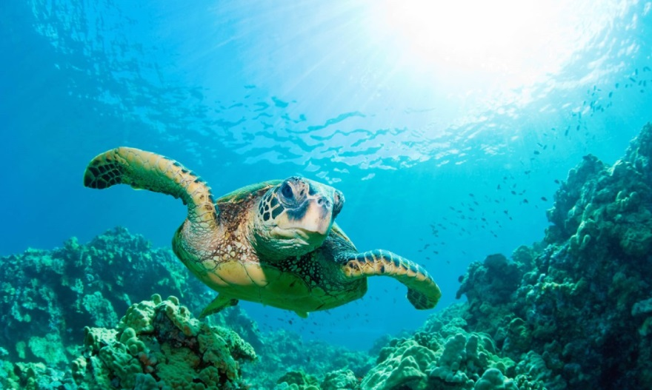
Home Learning Expectations
The expectation is that each child will read at least 4 times a week and learn weekly spellings which will be sent home. There will also be an additional half termly task usually set as part of a topic.
Home Learning
You can help your child’s learning at home by:
- Hearing them read a variety of books or comics and reading to your child. Remember to fill in their reading records or help them keep a reading log.
- Helping them to practise their spelling words in a variety of ways, for a short time each day.
- Talk to them about their topics.
- Play number games.

TURTLES CLASS
MRS PLANT, MRS GOUGH, MRS HUNT
YEAR 2
Please take time to read what we will be learning in school during next half term. If you have any questions please see the class teacher.

Home Learning Expectations
The expectation is that each child will read at least 4 times a week and learn weekly spellings which will be sent home. There will also be a weekly consolidation homework or topic homework.

Important
Please ensure your child brings an indoor and outdoor PE kit to school on Monday and leaves them at school during the week. It will be worn home on Thursday ready for Fit Friday.
Please send diaries in daily and homework books by Wednesday. Playtime snacks and drinks.

A snack is provided for playtime but children can bring their own fruit or vegetable snack if preferred. Children can bring their own water bottle, for water only. These should be washed every day.
Friday is spelling dictation day.
Friday from 3 to 3.30pm you are welcome to look at your child’s work on display in the classroom.
In Science we will:
- Observe and describe how seeds and bulbs grow into mature plants.
- Grow vegetables and herbs to eat.
- Investigate and describe how plants need water, light and a suitable temperature to grow
and stay healthy.

Our main Themes this Half Term
Maths overview
Children will continue to use equipment and pictorial representations to support their understanding and use vocabulary appropriately.
Multiplication and Division:
Know multiplication facts for the 2X, 5X and 10X tables, doubling and halving. We will look at patterns in multiplication and commutative law. Calculate mathematical statements for division within the multiplication tables and write them using the division (÷) and equals (=) signs. Recall and use division facts for the 2, 5 and 10 multiplication tables.
Length: Gain a better understanding of how to measure length. Understand what a metre is and what centimetres are and use them in real-life contexts.
Targets:
Consistent correct number formation
Read and spell numbers to 100
Compare and arrange numbers within 100
Count in 2,5,10s forwards and backwards from any number.

In Literacy we will:
Read both fiction and non-fiction books related to our topic. We will learn to
- Be consistent in our use of capital letters, full stops, question marks and exclamation marks.
- Use Alan Peat sentences.
- Learn to recognise and use the word classes, verb and adverb.
- Look at a range of purposes for writing and different audiences.
- Spell year 2 common exception (purple pen) words correctly.

Other areas of study.
Art/DT | Learning about the life and work of Lowry and copying his style. Drawing dragons. Designing and making moving pictures using levers.
RE | Easter – Resurrection. Key Question: Is it true that Jesus came back to life again?
PSHE | Jigsaw: Being Healthy
Music | Learning about pulse, rhythm and pitch and singing and playing instruments linked to the reggae song ‘Zootime’.
ICT | Word processing, audio and graphics.
Dragons s
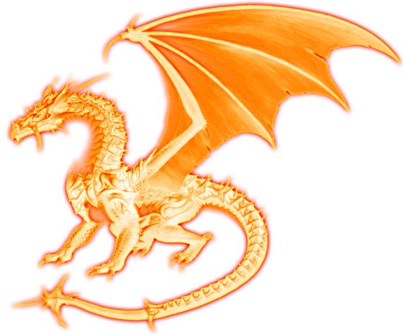

In humanities we will…
- Name, locate and identify characteristics of the four countries of the UK and their capital cities.
- Use atlases, maps and a globe.
- Use simple compass directions.

