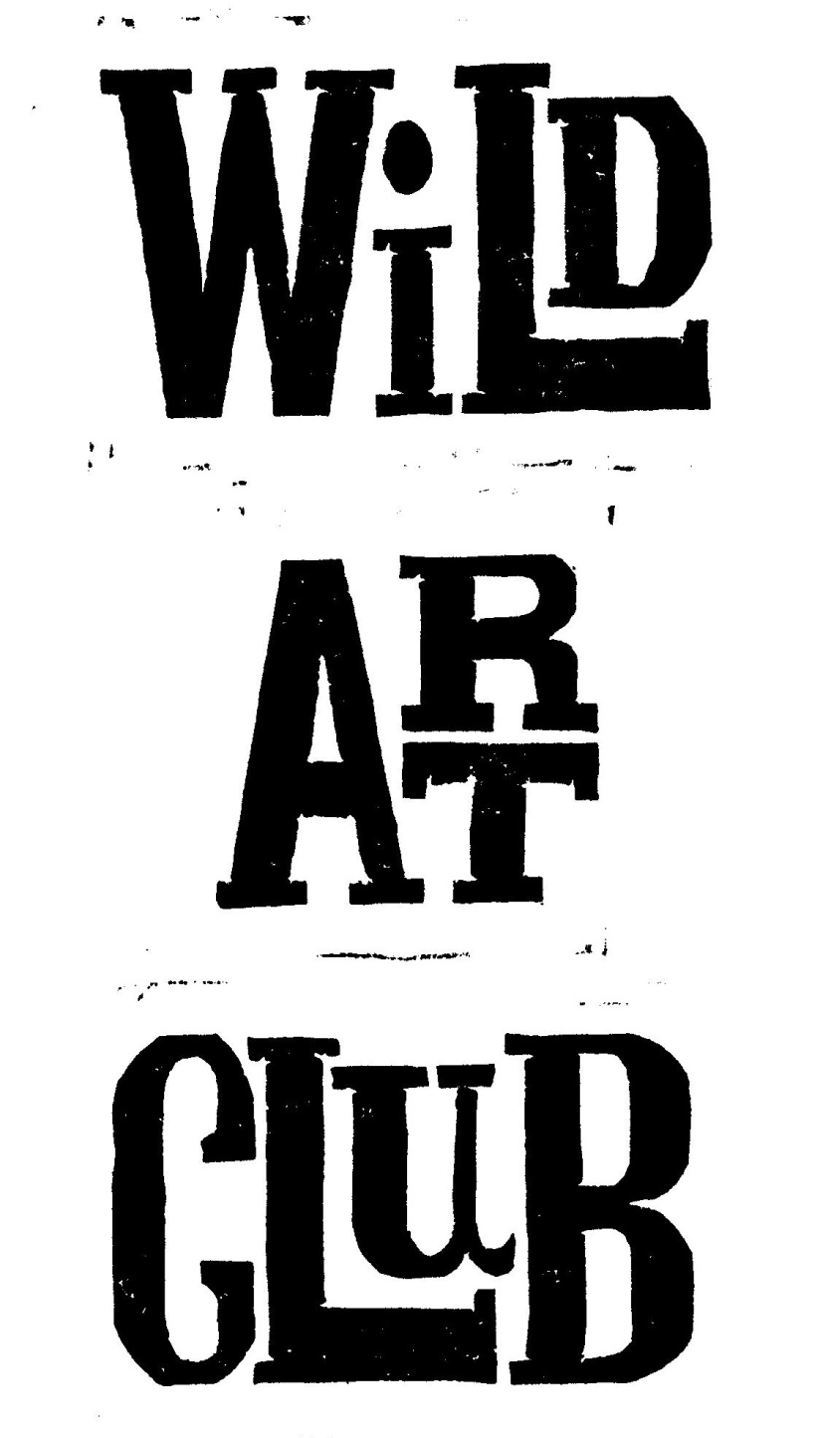

**Wild Art Club. Spring Term 2017.**

Enjoy Exploring Wildlife at School, through hands-on experience and Art & Craft activities with Maggie Spratt.

**Wild Art Club will run for 11 sessions** **during the Spring Term, for Years 1, 2, 3 & 4 on Tuesdays only.**

**Starting on 10th January & running until the 28th March, from 3.00- 4.30pm at a cost of £55 each.**

Please make sure that your child has old clothes and suitable footwear for outside, & an old painting shirt to wear, as sessions can get messy! We will be outside in the grounds when weather permits. A healthy snack is welcome, no sweets please. Good Behaviour is Expected At All Times. Please be on time to collect children at the end of each session.

**Cost for the term is £55.00, payable to Mrs. M. Spratt by 10th January 2016.**

(Payable as a single payment of £55, or two payments of £25 & £30 to be paid by the 10th January & the 21st February)

Consent Form & Payment must be returned by 10th Jan 2017 to ensure your child’s place, & numbers may be restricted depending on availability of adult helpers. Please detach and return form to School Reception. Please speak to me if there is a problem and I will try to accommodate you: [mrspratt@hotmail.co.uk /07929](mailto:mrspratt@hotmail.co.uk%20/07929) 832662

[mrspratt@hotmail.co.uk](mailto:mrspratt@hotmail.co.uk)

01258-837927/07929-832662

Child…………………………………………………………………………………………………………..………………………………

Address……………………………………………………………………………………………………………………………………………………..

Contact Telephone No…………………………………………………………………………………………………………………………….

Please state if your child has any relevant medical conditions/allergies…………………………………

I am happy for my child to be photographed for publicity………..…………………………………………………..

I enclose payment of **£45.oo for the term. ./ £25.00 for first ½ term.**

Signed……………………………………………………………………………………………………………………..…….Parent/Guardian

**Wild Art Club Spring Term 2017.**

Name of Child………………………………………………………………………………………………Year..………………………………

Address…………………………………………………………………………………………………………………………………………………

Contact Telephone No…………………………………………………………………………………………………………………………..

Please state if your child has any relevant medical conditions/allergies……………………………………………..………….

I am happy for my child to be photographed for publicity………..………………………………………………………..………

I enclose payment of £55.00 for the whole term / £25.00 for 1st half of Spring Term 2017. (Please circle.)

Signed………………………………………………………………………………………………..…………..……..…….Parent/Guardian