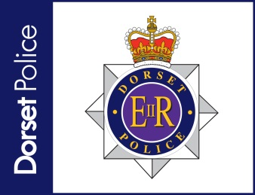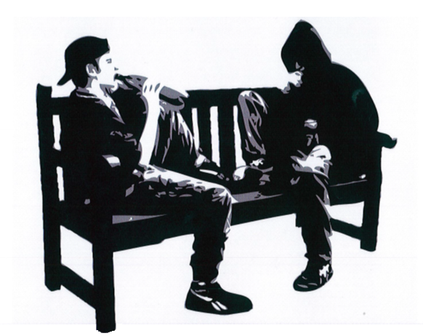

For more information please see www.gov.uk/coronavirus

Help the police to protect them from risk and harm.

Following Government advice it has never been more vital to know where your children are. By gathering in groups people are putting at risk those most vulnerable in our communities.

During patrols if officers come across groups we will be giving advice and requesting they disperse to their own homes.

**Do you know where your children are?**