**Home Learning**

You can help your child’s learning at home by:

* Listening, questioning and discussing with your child as they child read a variety of books. Please record in their homework diary when you have read with them.
* Helping them to practise their spelling words and times tables in a variety of ways - little and often!
* Encouraging independence- getting their own book bag ready, bringing in their PE kit etc.

[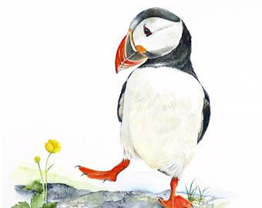](https://www.google.co.uk/url?sa=i&rct=j&q=&esrc=s&source=images&cd=&cad=rja&uact=8&ved=2ahUKEwiRjbeR_-PgAhVErxoKHfiRD3YQjRx6BAgBEAU&url=https://www.etsy.com/market/puffin_painting&psig=AOvVaw3LzstO1h52PGqztfd6zfMo&ust=1551634503243236)

**Home Learning Expectations**

The expectation is that each child will:

* Read at least 4 times a week
* Learn the spellings that are sent home. These will be tested on Fridays.
* Complete a maths or literacy homework activity once a week.
* Complete a half-termly topic homework

**Important**

Please ensure your child brings a PE kit to school on Monday and leaves it at school during the week. It can be taken home at the weekend. Please check that trainers fit comfortably.

Please remind your child to bring their spelling book in on Fridays.

**Friday is spelling and times-tables test day.**

**P.E is on Monday and Thursday.**

**Swimming is on Thursday for Year 3.**

**Open Mondays**

You are welcome to come into class on Monday afternoons from 3-3.30pm to look at your child’s work.

**Year 3 and 4: Puffins**

Spring Term 2 2019

**Class Teachers: Miss Grimshaw**

**Adult support: Mrs Hewish**

Please take time to read about what we will be learning in school during the next half term. If you have any questions please see Miss Grimshaw.

**Our Main Themes this Half Term**

Topic

In history this half term we will be continuing to answer the question “What was life like for a child during WW2?” We will be learning about; children’s toys and games, the different types of air raid shelter, what school was like, how lives of women changed and the impact WW2 had on families and the country.

We will also have our trip to Nothe Fort in Weymouth on Tuesday 5th March for an evacuee experience.

Maths

We follow the ‘Maths-no problem’ scheme. This adopts a spiral design with carefully built up mathematical concepts and processes. It incorporates the use of concrete resources, problem-solving and group work.

**Year 3 (Marvels):**

Length

Writing and solving problems with centimetres, meters and kilometres.

Mass

Reading and solving problems with grams and kilograms.

Volume

Measure, write and solve problems involving volume in millilitres and litres.

**Year 4 (Justice League):**

Multiplication and division

Multiplying and dividing numbers with up to 4 digits.

Graphs

Drawing and reading picture, bar and line graphs.

Fractions

Finding equivalent fractions, mixed numbers, improper fractions and how to add and subtract fractions.

Literacy

Over this half term, we are going to link all of our writing outcomes to our topic. Our first piece of writing will be a newspaper report about an enemy plane crash in a rural village. The third and final piece of writing will be a description setting of hiding in an underground station during an air raid. It is also book week this half term and we will be focusing on ‘rhyme’.

PE

In P.E we are working with Mr Daley on Dance, using lots of different inspirations. In our other PE lessons, we will be working on our balance and ball skills. Year 3’s will be having swimming lessons with Miss Wittman.

**What was life like for a child during WWII?**

[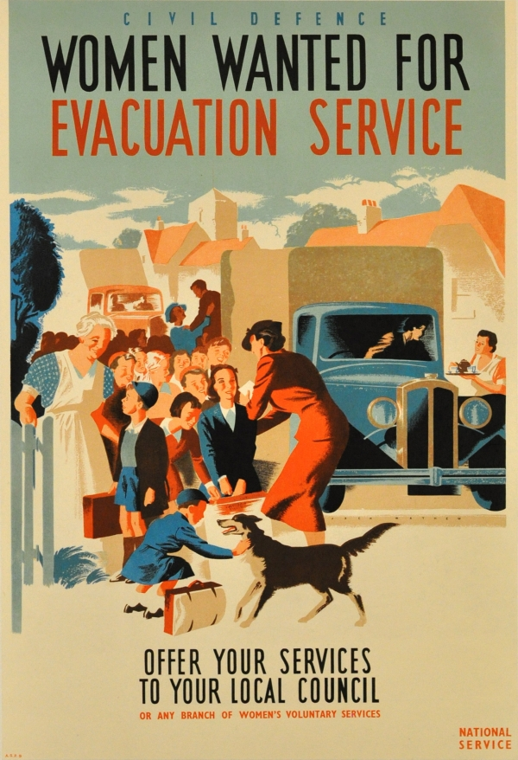](https://www.google.co.uk/url?sa=i&rct=j&q=&esrc=s&source=images&cd=&cad=rja&uact=8&ved=2ahUKEwiGnOTE_-PgAhUixoUKHUnECjUQjRx6BAgBEAU&url=https://antikbar.co.uk/original_vintage_posters/war_posters/women_wanted_wwii_evacuation/PW0166/&psig=AOvVaw0ECanpP9SBwUq6R0NjaJKi&ust=1551634584110817)

Music

We will spend much of this term learning and perfecting the songs for our DASP performance on 20.03.19. We will also learn some songs that were sang as entertainment during WW2.

Science

In Science we will be looking at Forces and Magnets. We will compare how things move on different surfaces; learn how magnetic forces work; compare and group together everyday materials and investigate magnets attracting and repelling each other.

P.S.H.E- Jigsaw

This half term, we will be focussing on ‘Healthy Me’. We will be learning about how exercise affects our body; especially our heart and lungs. We will also be learning about how to keep our body safe and healthy and how important it is to take care of it.

R.E.

We are learning to recall key events in the Easter story and to understand why Jesus’ crucifixion symbolises hope for Christians.

Art

In art we will be completing our Blitz paintings, making Anderson shelter models and creating a sculpture out of plastic waste collected in school