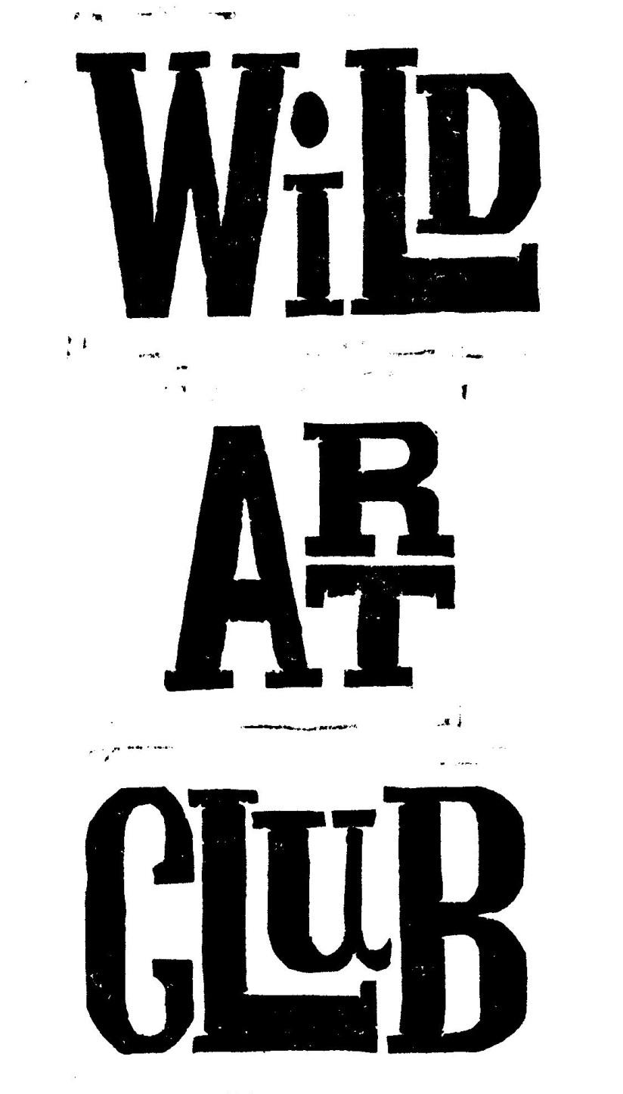 Please speak to me if there is a problem and
Follow the club on Instagram to see the children’s artwork:- @wildartclub and @maggie.spratt
Wild Art Club. Spring Term 2019.
Enjoy Exploring Wildlife at School, through hands-on experience and Art & Craft activities, with Maggie Spratt.
Wild Art Club will run for 10 sessions during the Spring Term on Tuesdays, from 3pm to 4.30pm.
Starting on 15th Jan – 26th March, at a cost of £50 each.
Open to Years 1, 2, 3 & 4.
Please make sure that your child has an old painting shirt
to wear, as sessions can get messy! A healthy snack is welcome, no sweets please. Good Behaviour is Expected At All Times. Please be on time to collect children at the end of each session.
Cost for the term is £50.00, payable by cheque, cash or BACS to Mrs M Spratt
Sort Code 202662; Account Number: 60703338
Payable as a single payment of £50 by 15th Jan, or two payments of £25 to be paid by the 15th Jan & £25 to be paid by the 26th Feb 2019
Consent Form & Payment must be returned by 15th Jan 2019 to ensure your child’s place, & numbers may be restricted depending on availability of adult helpers. Please detach and return form to School Reception.
Please speak to me if there is a problem and I will try to accommodate you: mrspratt@hotmail.co.uk
01258-837927/07929-832662

Wild Art Club Spring Term 2019.
Name of Child………………………………………………………………………………………………Year..………………………………
Email Address………………………………………………………………………………………………………………………………………
Contact Telephone No…………………………………………………………………………………………………………………………..
Please state if your child has any relevant medical conditions/allergies……………………………………………..………….
I am happy for my child to be photographed for publicity………..………………………………………………………..………
I enclose payment of £50.00 for the whole term or £25.00 for first ½ Spring Term 2019 / £25.00 for 2nd ½ Spring Term 2019. (Please circle as applicable).
Signed…………………………………………..………Print Name……………………….....…………..……..…….Parent/Guardian

