Milborne Message 24.01.2020

Message from Sharon Hunt!

Dear Parents,

We are getting ever closer to getting the new play equipment, thanks to the help from parents. The new grass seed has been planted and soon the work should start. Watch this space.

We are reviewing the curriculum and the curriculum newsletters have therefore changed. Please be patient while we work through this and I hope you will find the new versions really helpful and informative and easier to read. Please watch out for our all new knowledge organisers coming soon. See the sneak preview below.
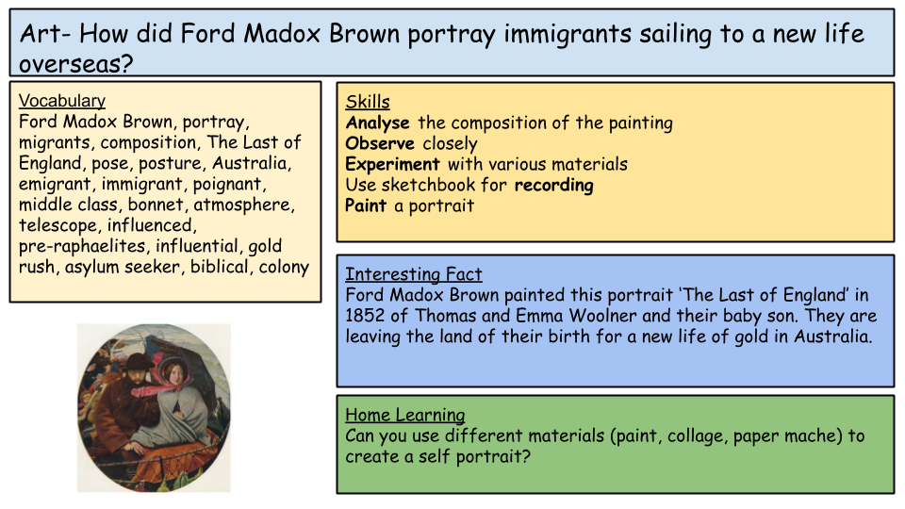

We have talked a lot about the importance of reading all the way through school, and I think you will find the link below attached really informative.

https://literacytrust.org.uk/blog/reading-children-so-powerful-so-simple-and-yet-so-misunderstood

The GTAT school council met during the week to discuss ways of improving our environment. The children shared lots of ways that across the schools we could recycle and reuse items that are common to all our GTAT schools.

I have been out of school on Trauma Informed Schools training - this is an intensive course over the next two terms. When I met with parents last, I talked about having regular meetings to feedback new learning. I will be putting together dates shortly to do this .

The Sun Newspaper - Thank you for all the tokens handed into the office so far. We have now reached our target! A very big THANK YOU to Maisie Pavey’s Grandparents, Richard and Jean Pavey and Mrs Sabrina McQuire of M B Wilkes and their team of drivers, especially Shaun Joyce, for collecting the majority of the tokens and for painstakingly cutting them all out. I will be sending off the tokens shortly and we look forward to receiving the books in due course.

Tapestry We have had some lovely feedback both from parents and children about how they enjoy using Tapestry. If you haven’t accessed it as yet a reminder link has been sent. Please check junk/spam mail boxes.

As you know we subscribe to Doodle Maths and English so please make sure we are getting good value for money by making these a regular part of your child’s activities at home. If you haven’t tried them yet then now is a good time to start. They are personalised to your child’s level and balance challenge and building confidence really well. The children who use them regularly are making very good progress across key areas of these subjects and have lots of fun doing so. Lydia, from Doodle, will be visiting Milborne First School on Thursday 12th March and will be running a parent workshop from 2.15-2.45. During this workshop, she will give you an overview of how Doodle works, and the best ways of supporting and encouraging your child(ren) with using Doodle at home. She would love it if you are able to join her! Please could parents consent via Schoolcomms if you are able to attend. Thank you.

We also subscribe to Rock Stars Times Tables, but this hasn’t been used so much recently but has had excellent results in the past. I know some of the children had mislaid passwords so we have reissued to Year 3 and 4 currently and they should be in their class diaries. I have challenged the Year 4s to a Times Tables showdown each week, starting with 2x tables today. Speed is key here so practise will be needed.

Well done to Joshua who was the champion of the 2x tables but it was very competitive!

Heads up! 5x tables next week.

Yours sincerely,
Sharon Hunt

Key information
- Hooke Court - Thank you to all the Year 4 parents who have either paid in full or have been making contributions towards the Hooke Court Residential trip. Just a reminder that Full payment is due by 3rd April 2020. There will be a Hooke Court parent and pupil meeting on the 12th February starting at 3:10pm after school. Please could parents consent via Schoolcomms your attendance. Thank you.
- Reception - Please could all parents consent via Schoolcomms for the Dance Festival @ St Mary’s on the 31st January 2020 (next Friday).
- Year 4 - Please could all parents consent via Schoolcomms regarding the Trees4Dorset transport to Bagber Farm, Milton Road on 6th February 2020. Weather appropriate clothing will be required, wellies, waterproof and warm coat, healthy snack and a water bottle are essential.
- OE - If there are any parents who are able to help for a couple of hours during our OE lessons in the afternoon on either a Wednesday or Thursday (see Website Calendar for dates), please could you let Miss Wittman know. A rota will be set up, so if you are able to help with any dates over the course of the year Adrian our OE instructor would be most grateful. Thank you.
- SCHOOLCOMMS - Please could all parents create their accounts before 10th February in order for any issues to be resolved before the Half-term break. Thank you.
Club Bookings:- Please can we ask parents to ensure that you have booked your child into the relevant clubs needed before 11pm the day before. If your child is not booked in, this creates arrears on your account, as well as extra admin and time for staff, which we are trying to reduce with the new system.
If you are having any issues please either come into the office or phone / email the office and I will endeavour to answer all your questions. Thank you.
- Safer Internet:- More information about online safety is available on the school website.

Key Dates:-
- 31st Jan - Reception Dance Showcase @ St Mary’s Middle School (Consent via Schoolcomms)
- 6th Feb - YEAR 4 - Tree Planting with Trees 4 Dorset (am) (Consent via Schoolcomms)
- 6th Feb - Year 2 - Bud Identification (pm)
- 11th Feb - Robins Class Assembly (9am - 9:30am)
- 12th Feb - Year 4 Hooke Court Parent meeting (3:10pm till 3:45pm)
- 13th Feb - LAST DAY OF TERM
- 14th Feb - INSET - Teacher Training day (no children in school)
- 17th Feb to 21st Feb - Half Term Break
- 24th Feb - First Day back for children
- 26th Feb - The Book People Bus Visit (8:30am till 4pm)
- 28th Feb - Rabbits - Maths Stay and Play (9am till 10:20am)
- 4th March - School Nurse Drop in Session (8:45 - 9:15)
- 4th March - Raccoons Singing Festival Rehearsal @ THS (consent via Schoolcomms)
- 4th March - DASP Singing Festival Concert (6pm @ Thomas Hardye School, Dorchester)
- 5th March - World Book Day
- 6th March - CLASS Photos
- 13th March - Comic Relief Red Nose day
- 20th March - School Council Sale (raising money for Koalas)
- 24th March - Parent Consultations
- 26th March - Parent Consultations
- 3rd April - Egg rolling / Egg Decoration judging morning (Only 1 egg to be decorated)
- 3rd April - LAST DAY OF TERM (pick-up @ 1:15pm finish)
- 6th April to 17th April - Easter School Holidays
- 20th April - First Day back for children
- 22nd to 24th April - Hooke Court Residential Trip (Year 4’s)
Wider Community Information:-
- FAMILY INFORMATION SERVICE - Please follow the link to the latest newsletter and information:- https://mailchi.mp/dorsetcouncil/novemberfisnewsletter?e=5ad5011868
- Parenting Skills and Strategy Sessions - Please see the attached flyer
- Baby & Toddler Groups - Please visit www.playandbloom.co.uk for more information.
- AS Divas and Dudes meetings - Please see the flyer in Main Reception for more details.
- Dorset Council, Activity and Health Team - Please see the link to their latest newsletter
https://mailchi.mp/dorsetcouncil/make-2020-your-year-to-get-active?e=5ad5011868

