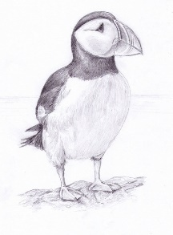
Dear parents and children,

The year 3 Puffins have produced this newsletter to give you some insight into what has been happening around school this half term.
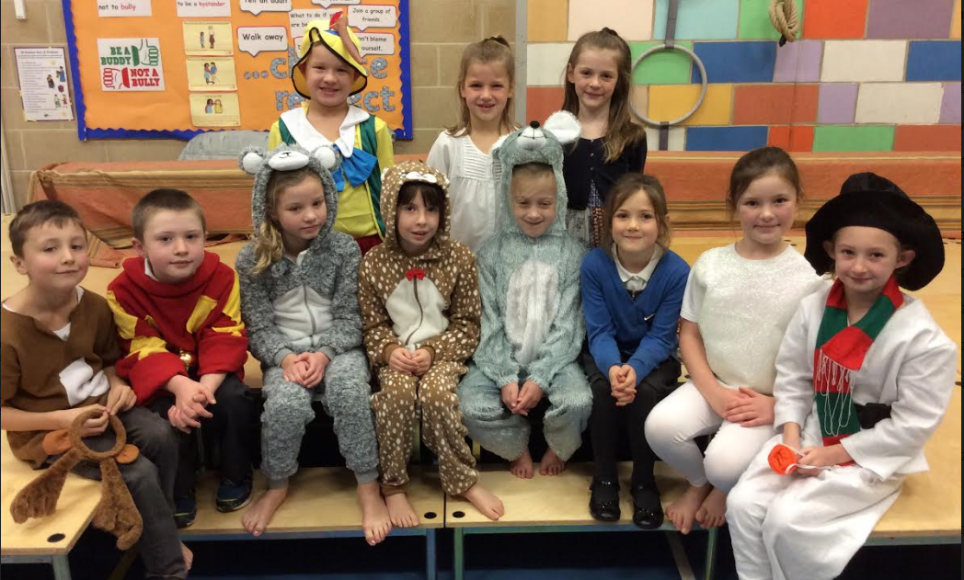

These 7 and a half weeks have flown by and have been filled with lots of exciting activities both in and out of the classroom.
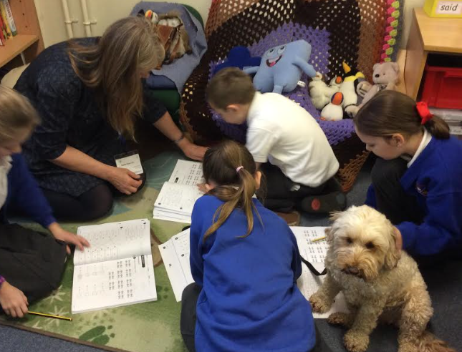
We have had a new member of the class who has joined us some weekday mornings, Elsie the dog! She has listened and supported us when we have been unsure and has encouraged us to keep going when we have lost our motivation.
At the start of the half term, we wrote a diary imagining that we had been to a Diwali celebration, linking to our learning in RE last half term. After learning about the features that we needed for our diary, one of which is colloquial writing which we really enjoyed trying to say, we then spent a couple of lessons reminding ourselves all about the celebrations, and the preparations involved in them too. When we finally got down to our writing we had the lights down low and lit lots of candles to try and replicate the “light festival” feel.
Our topic this half term has been about sustainability. We have learnt some fascinating facts about the energy and resources that we use, and how we can try to live more sustainably. We think this is really important and have set up roles of responsibility around the school to monitor our sustainability as a school. We have also made some of our very own wind turbines made completely out of recycled materials.

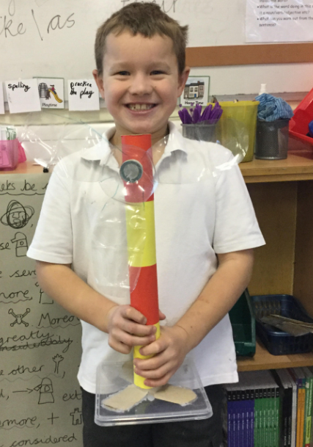
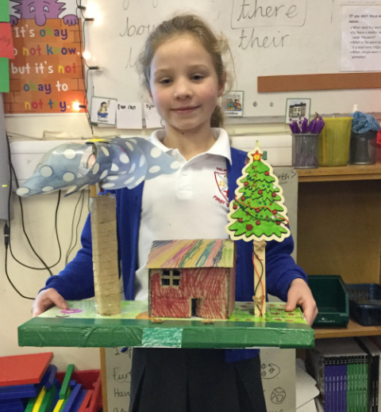
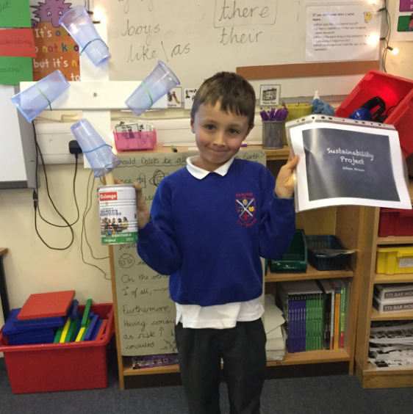
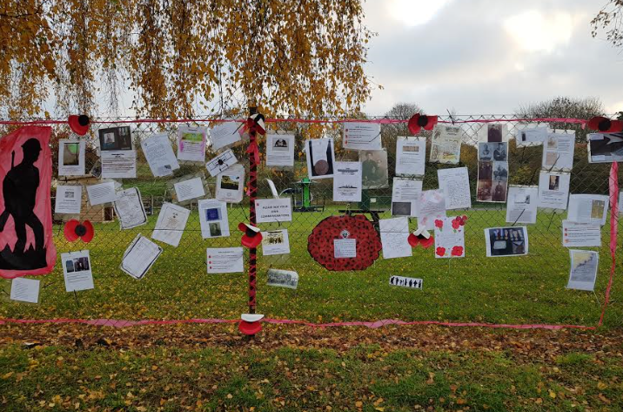
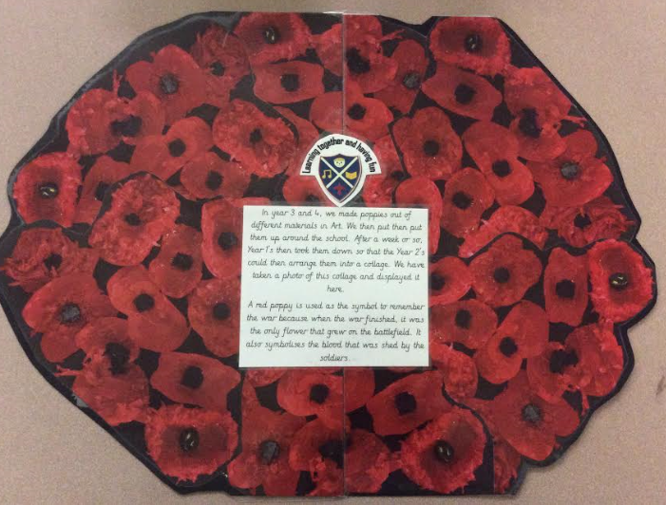
Our last big piece of writing was a discussion text with the question, “Is recycling a good idea?” This generated great discussions with points both for and against the idea and some excellent reasoning to back up opinions.

At the start of November, Puffins class made poppies to put up around the school as part of Remembrance day. After they had been up for a few weeks, we made a collage out of them and, along with other members of the community, put them up as part of a ‘Memory wall’ outside the village hall to mark the centenary of the end of WW1.
Outside of the classroom the year 3’s spent a day with Trees for Dorset. We looked around the school grounds to see the diversity of trees that we have, we found 27 varieties!! We then used the leaves from 6 of these varieties and set up a wormery in our classroom investigating which of these leaves are the worms favourites.
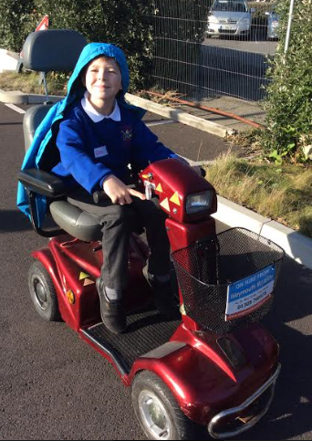
Year 3’s have also been having swimming lessons once a week at Milton Abbey. This is the first time that we have had lessons with school and we have found it great fun, and cannot wait until the next half term when we get to go again.
As a whole class, we went to SafeWise in Weymouth and had an excellent day learning about fire and road safety, we even got to ride mobility scooters!

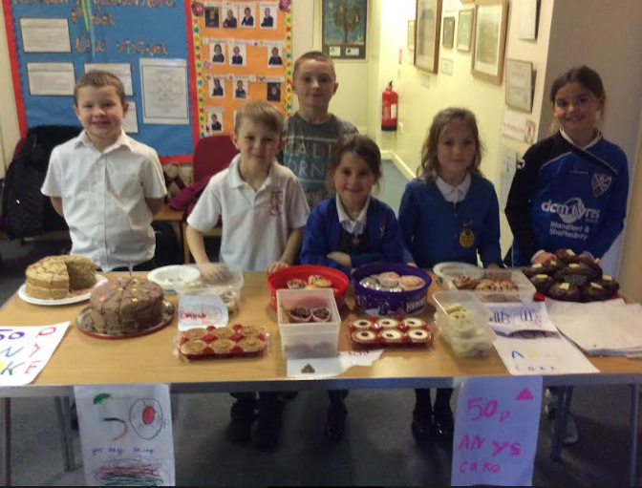
Towards the end of November, school council arranged two events for Children in Need, the first was a spotty dress up day and the second was a cake sale. The cake sale especially was a great success, the cakes were so tasty that people were queuing out of the door in the rain! We are very proud that with both events together we managed to raise £126 so thank you!

Around the rest of the school
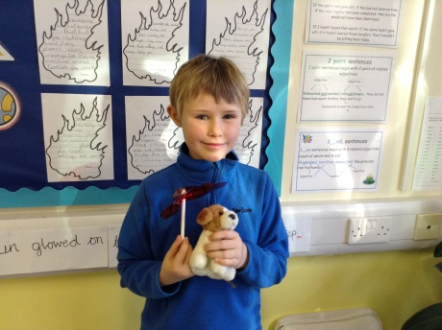
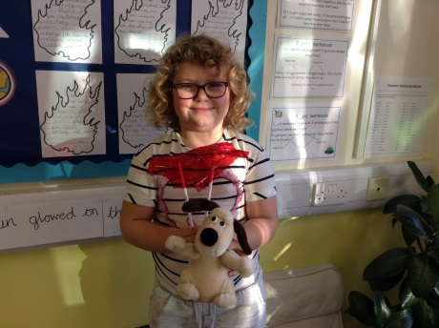
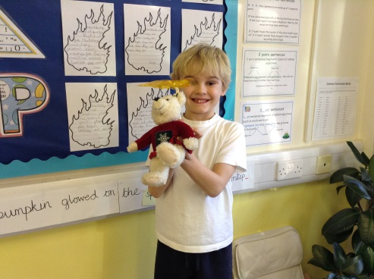
In year 2, Turtles class, we have been finding out about waterproof materials by designing and making umbrellas for our teddies.
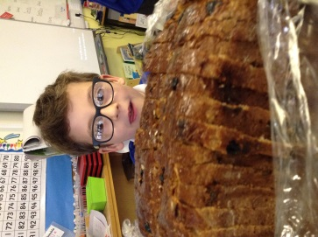
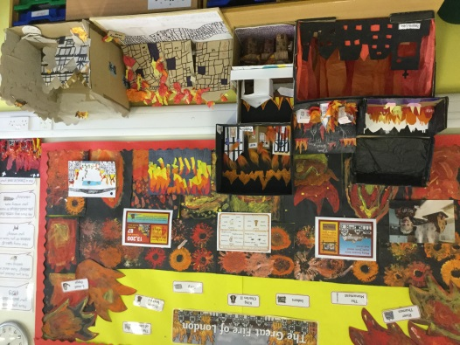
In Humanities we have been finding out about the great fire of London. We have written poems, painted scenes, made amazing dioramas and even baked cakes from that time!

In Year 1, Dolphins class, this half term our topic has been the Great Fire of London. In Art we built our own Tudor houses using cardboard, paint, paper and straw.
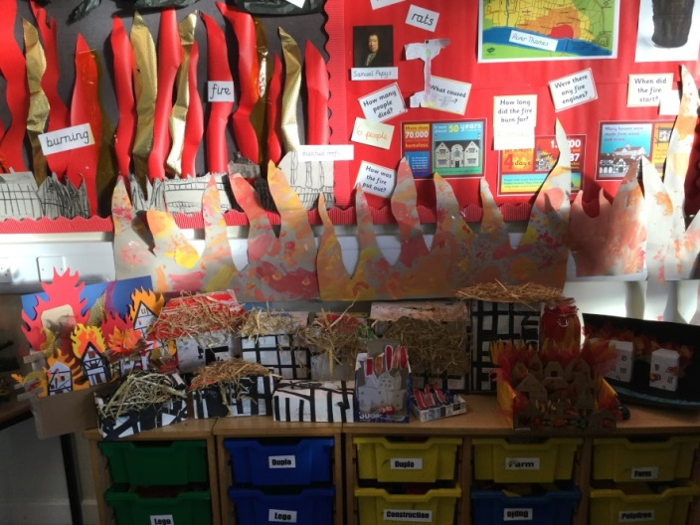
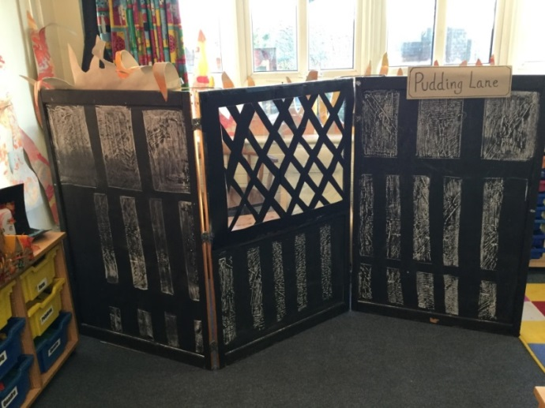

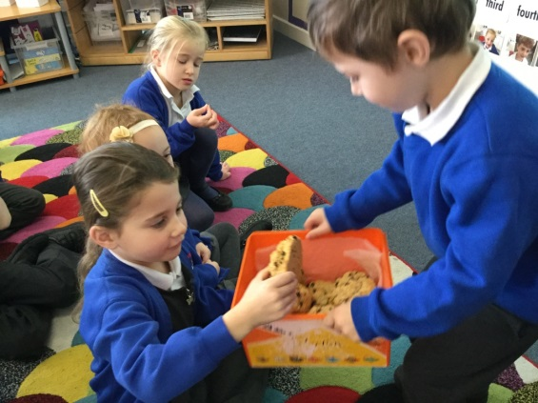
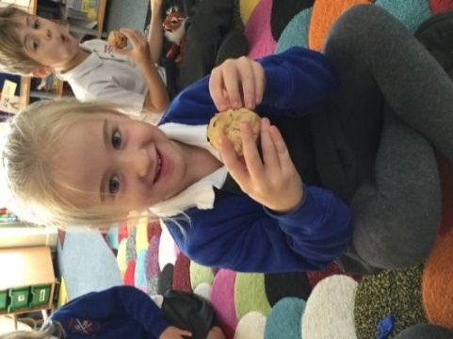
For our homework, some of us baked some rock cakes. These were the cakes that would have been made in Pudding Lane back in 1666. They were delicious!

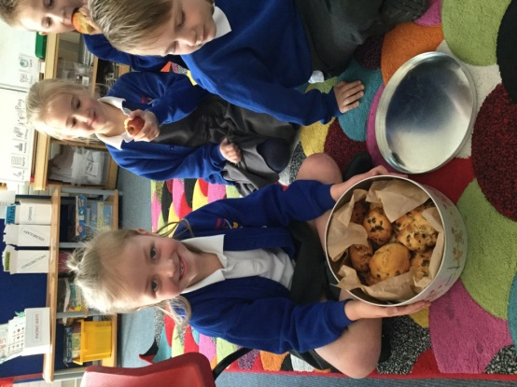

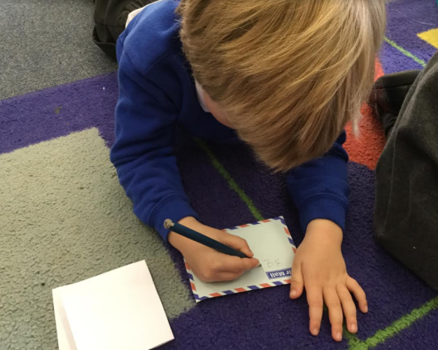
In Reception, Seahorses, we have been busy earning our elf ears at Santa School! If you came into Seahorses you would see us carrying out present surveys, writing lists and letters to be posted and designing then building toys in the workshop. We made our own wrapping paper to decorate the box our toys go in before adding ribbons and labels. These are all added to the sack that our Father Christmas delivers in the sleigh we built in the scrap pod, following a route drawn out on paper showing the way from the Artic to Milborne.
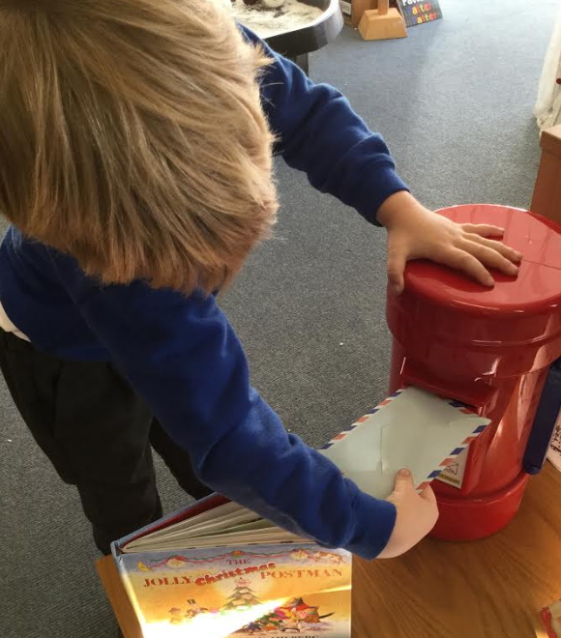

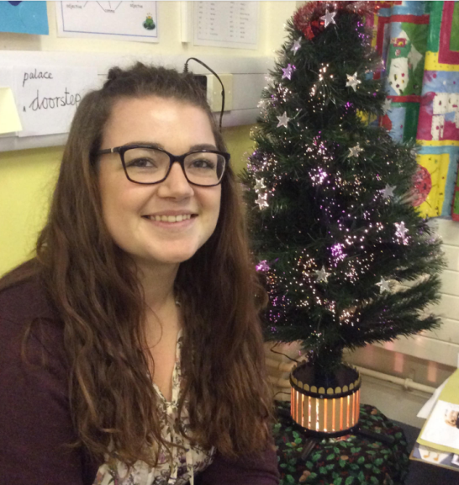
Year 3 Puffins chose to interview Miss Dunne. She is a student teacher who has been working in Turtles class since half term and she’s been great! We wish her lots of luck with the rest of her PGCE.
Why did you choose our school?
It was allocated to me by University
What is your favourite type of food?
Roast Dinner
What would you like for Christmas?
A nice and shiny new Car
Do you have a brother or a sister?
Yes, I have one brother and one sister. I’m the youngest.
Do you have any pets, and if so what are they?
Yes, a dog called Goodwood, he is a black lab crossed with a Springer.
What is your favourite thing about Christmas?
Spending time with my family.
What is your favourite Christmas film?
It’s got to be the first Nativity film
What is your favourite Christmas song?
Fairy-tale of New York by The Pogues
What is your favourite thing about teaching?
I love that every day is different
What did you want to be when you were little?
A popstar
Amongst all of this, we have also managed to squeeze in practicing our Christmas play, The Night before Christmas!!
And on that note, we would like to wish you all a Merry Christmas and a Happy New Year!!

