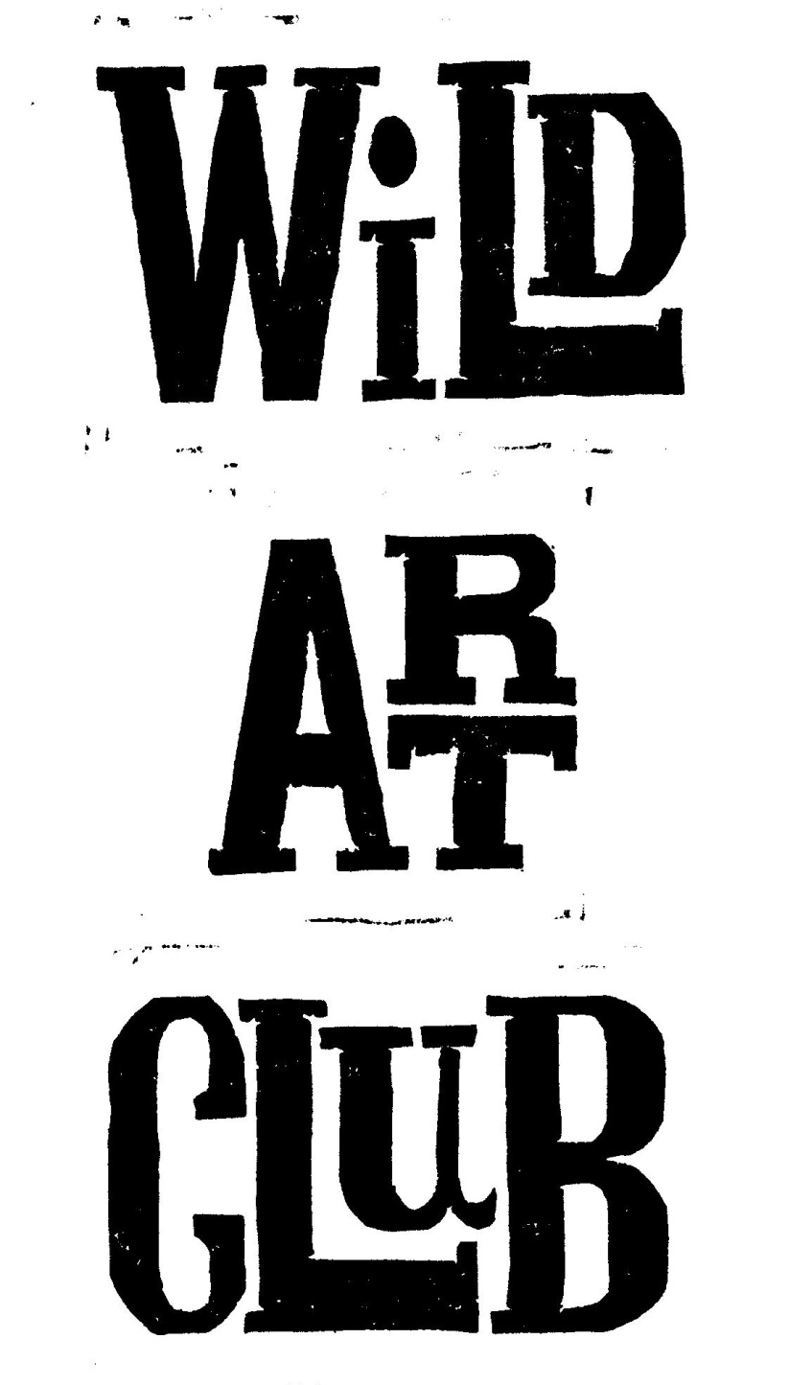 Please speak to me if there is a problem and
Wild Art Club. Spring Term 2018.
Enjoy Exploring Wildlife at School, through hands-on experience and Art & Craft activities, with Maggie Spratt.
Wild Art Club will run for 10 sessions during the Spring Term on Tuesdays, from 3pm to 4.30pm.
Starting on 9th Jan – 20th March, at a cost of £50 each.
Open to Years 1, 2, 3 & 4.
Please make sure that your child has old clothes or an old painting shirt to wear, as sessions can get messy! A healthy snack is welcome, no sweets please. Good Behaviour is Expected At All Times. Please be on time to collect children at the end of each session.
Cost for the term is £50.00, payable by cheque, cash or BACS to Mrs M Spratt Sort Code 202662 Account Number: 60703338 Payable as a single payment of £50 by 9th Jan, or two payments of £25 to be paid by the 9th Jan & the 20th Feb 2018.
Consent Form & Payment must be returned by 9th Jan 2018 to ensure your child’s place, & numbers may be restricted depending on availability of adult helpers. Please detach and return form to School Reception. Please speak to me if there is a problem and I will try to accommodate you: mrspratt@hotmail.co.uk 01258-837927/07929-832662

01258-837927/07929-832662
Child…………………………………………………………………………………………………………..………………………………
Address……………………………………………………………………………………………………………………………………………………..
Contact Telephone No…………………………………………………………………………………………………………………………….
Please state if your child has any relevant medical conditions/allergies…………………………………
I am happy for my child to be photographed for publicity………..…………………………………………………..
I enclose payment of £45.oo for the term. ./ £25.00 for first ½ term.
Signed……………………………………………………………………………………………………………………..…….Parent/Guardian

Wild Art Club Spring Term 2018.
Name of Child………………………………………………………………………………………………Year..………………………………
Address…………………………………………………………………………………………………………………………………………………
Contact Telephone No…………………………………………………………………………………………………………………………..
Please state if your child has any relevant medical conditions/allergies……………………………………………..………….
I am happy for my child to be photographed for publicity………..………………………………………………………..………
I enclose payment of £50.00 for the whole term or £25.00 for first ½ Spring Term 2018 / £25.00 for 2nd ½ Spring Term 2018. (Please delete as applicable).
Signed………………………………………………………………………………………………..…………..……..…….Parent/Guardian

