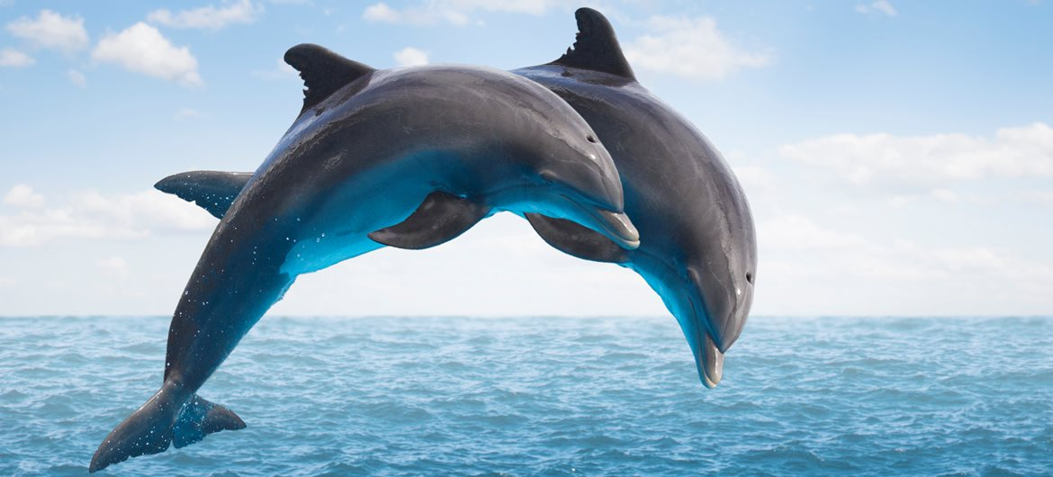

**DOLPHINS CLASS**

**MRS ANDREWS and MRS PRATT**

**YEAR 1**

Please take time to read what we will be learning in school during next half term. If you have any questions please see the class teacher.

Don’t forget Book Week is 4th March. You can dress up as you favourite character on Thursday 7th March.

**Important**

Please ensure your child brings an indoor and outdoor PE kit to school on Monday and leaves them at school during the week. It can be taken home for the weekend.

Please send diaries in daily and homework books on Friday.

Friday is spelling test day.

Wednesday is Power Write day.

Wednesday from 3 to 3.30pm you are welcome to look at your child’s work on display in the classroom.

**Home Learning Expectations**

The expectation is that each child will read at least 4 times a week and learn weekly spellings which will be sent home. There will also be an additional half termly task usually set as part of a topic.

**Home Learning**

You can help your child’s learning at home by:

Hearing them read a variety of books and comics and reading to your child.

Asking questions about topics they are covering.

Encourage your child to log onto Espresso.

Reinforce what they have learnt in Maths (see half term objectives overleaf)

**Maths overview**

Read, write and interpret mathematical statements involving addition (+), subtraction (–) and equals (=) signs.

Add and subtract 1-digit and 2-digit numbers to 20, including zero.

Use number bonds and related subtraction facts within 20.

Given a number, identify one more and one less.

Solve one-step problems that involve addition and subtraction.

Solve one-step problems involving multiplication

Use multiplication and division facts for the 2, 5 and 10 multiplication tables.

Introduce division by grouping equally and then sharing equally.

Find fractions, halves and quarters of shapes, objects and numbers.

In literacy we will be…

* Writing sequences of sentences using capital letters and full stops correctly.
* Improving our handwriting and joining letters
* Using exclamation and question marks
* Using and to join clauses
* Learning spelling rules
* Writing poetry
* Using adjectives

**Our main Themes this Half Term**

In Science we will be learning

* The seasons and observe changes in weather
* Use our observational skills to answer questions and record findings
* Naming parts of plants
* Naming plants and trees
* Growing plants

In Geography we will be learning to:

* Name, locate and identify characteristics of the four countries of the UK and their capital cities
* Use atlases, maps and a globe
* Use simple compass directions



In RE we will be exploring the question ’Did Jesus come back to life?’

Retelling the Christian Easter story and looking at why it is important to Christians.

In PE we will be…

Improving our coordination with ball skills and balancing with a partner

In Art and Design we will be…

* Learning about the life and work of Lowry
* Drawing dragons
* Designing and making moving pictures using levers

Dragons

In our PSHE sessions we will be focusing on the topic Healthy Me

* Healthy choices
* Keeping clean
* Medicine safety
* Road safety

.