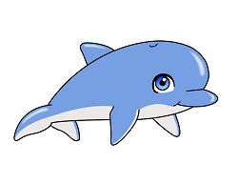
Dolphins Class Half Term Homework
This half term we would like you to learn a poem or nursery rhyme of your choice.
You can use props or actions during your performance. With your permission, we will record your performance and put it on to Tapestry and the class page.
Let us know when you are ready to perform your poem anytime before Half term.
Have fun!
Mrs Andrews and Mrs Pratt

