**Home Learning**

You can help your child’s learning at home by:

* Listening, questioning and discussing with your child as they child read a variety of books. Please record in their homework diary when you have read with them.
* Helping them to practise their spelling words and times tables in a variety of ways - little and often!
* Encouraging independence- getting their own book bag ready, bringing in their PE kit etc.

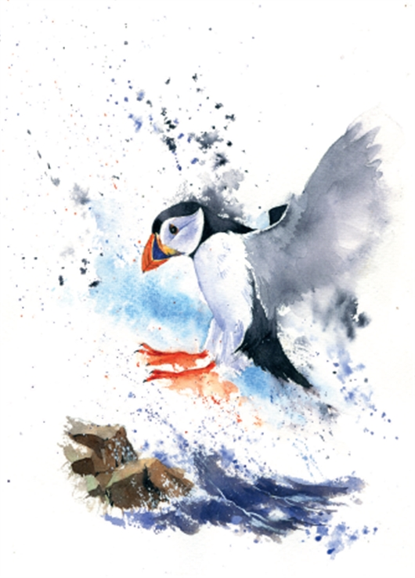

**Home Learning Expectations**

The expectation is that each child will:

* Read at least 4 times a week
* Learn the spellings that are sent home. These will be tested on Fridays.
* Complete a maths or literacy homework activity once a week.
* Complete a half-termly topic homework

**Important**

Please ensure your child brings a PE kit to school on Monday and leaves it at school during the week. It can be taken home at the weekend. Please check that trainers fit comfortably.

Please remind your child to bring their yellow spelling book in on Fridays.

**Friday is spelling and times-tables test day.**

**P.E is on Monday and Thursday.**

**Swimming is on Thursday for Year 4.**

**Open Mondays**

You are welcome to come into class on Monday afternoons from 3-3.30pm to look at your child’s work.

**Year 3 and 4: Puffins**

Summer Term 2019

**Class Teachers: Miss Grimshaw**

**Adult support: Mrs Hewish**

Please take time to read about what we will be learning in school during the next half term. If you have any questions please see Miss Grimshaw.

Topic  
This term in our topic sessions, we will answer the question: What is the Jurassic Coast and what can we learn from it? We will learn where the Jurassic Coast actually is and become rock and fossil detectives. We will also make models of the coast, learn about Mary Anning and discover how the coast has changed over time and how the Jurassic Coast links the past to the present.

Maths

We follow the ‘Maths-no problem’ scheme. This adopts a spiral design with carefully built up mathematical concepts and processes. It incorporates the use of concrete resources, problem-solving and group work.

**Year 3 (Marvels):**

Volume

Measure, write and solve problems involving volume in millilitres and litres.

Money

Naming, adding and subtracting money and applying this to solve word problems.

Time

Telling and measuring time in seconds, minutes, hours and days.

**Year 4 (Justice League):**

Multiplication and division

Multiplying and dividing numbers with up to 4 digits.

Graphs

Drawing and reading picture, bar and line graphs.

Fractions

Finding equivalent fractions, mixed numbers, improper fractions and how to add and subtract fractions.

**Our Main Themes this Half Term**

PE

In P.E we are working with Mr Daley on striking and fielding. In our other PE lessons, we will be working on applying physical skills, balance and agility. Year 4’s will be having swimming lessons with Miss Wittman.

Literacy

Over this half term, we are going to link all of our writing outcomes to our topic, both pieces will be non-fiction. Our first piece of writing is going to be an explanation folk tale set in Dorset, explaining why something is the way it is. We will then go on to look at the elements of fairy tales and we will then write our own short fairy tale based in Dorset.

**What can we learn from the Jurassic Coast?**

Science

In Science we will be looking at plants. We will be focussing on what plants need to grow; parts of the plant and their function; how water and nutrients get to parts of the plant and the life cycle of a plant.

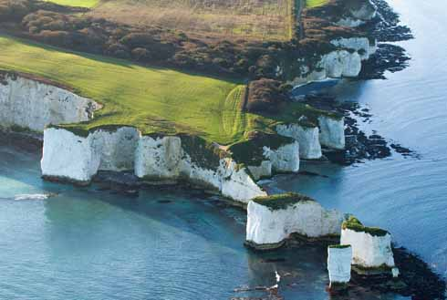

Music

This half term (and next half term too), a brass teacher will be coming in from DASP music to teach all of Puffins some brass instruments, such as the Cornet, Trumpet and Trombone.

P.S.H.E- Jigsaw

This half term, we will be focussing on Relationships. We will be looking at family roles and relationships; friendships; keeping ourselves safe; being a citizen and celebrating our relationships.

R.E.

We are focussing on Hinduism and learning to understand the Hindu belief that there is one God with many different aspects.

DT

During our DT sessions for this half term (and next half term too) we will be researching and designing our own pair of slippers. We will then make them using our sewing skills.