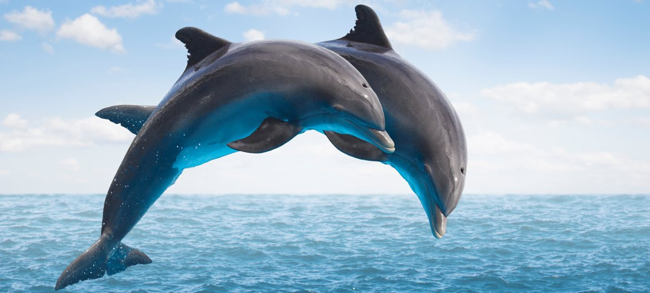

**DOLPHINS CLASS**

**MRS ANDREWS and MRS PRATT**

**YEAR 1**

Please take time to read what we will be learning in school during next half term. If you have any questions please see the class teacher.

ANY BOXES ETC FOR DT WOULD BE VERY WELCOME

Curriculum Leaflet

**Home Learning**

You can help your child’s learning at home by:

Hearing them read a variety of books and comics and reading to your child.

Asking questions about topics they are covering.

Encourage your child to log onto Espresso.

Reinforce what they have learnt in Maths (see half term objectives overleaf.)

Please see the class page on the school website for details.

**Home Learning Expectations**

The expectation is that each child will read at least 4 times a week and learn weekly spellings which will be sent home. There will also be an additional half termly task usually set as part of a topic.

**Home Learning**

You can help your child’s learning at home by:

Hearing them read a variety of books and comics and reading to your child.

Asking questions about topics they are covering.

Encourage your child to log onto purple Mash and Espresso.

Reinforce what they have learnt in Maths (see half term objectives overleaf)

**Important**

Please ensure your child brings an indoor and outdoor PE kit to school on Monday and leaves it at school during the week. It can be taken home for the weekend.

Please send in reading books, diaries and homework books in daily.

Friday is spelling test day.

Wednesday is Power Write day.

Wednesday from 3 to 3.30pm you are welcome to look at your child’s work on display in the classroom.

**Home Learning Expectations**

The expectation is that each child will read at least 4 times a week and learn weekly spellings which will be sent home in their homework books. There will be additional half termly activities set as part of the topic. Please see homework books for details.

In History we will…

* Understand why the fire broke out and why it spread so far for so long
* Sequence events
* Learn what an eye witness is and learn about the diary of Samuel Pepys
* Understand that London was rebuilt and with different materials

In literacy, we will be…

* Writing diary entries
* Using the suffixes –ing, -ed, -er and –est when writing poetry
* Improving writing through the use of correct punctuation and handwriting.
* Using and to join words and sentences
* Spelling the days of the week

**Maths overview**

Children will continue to use equipment and pictorial representations to support their understanding and use vocabulary appropriately.

Children will learn to…

* understand positional language such as first, second, third as well as directional language for left and right
* read and spell numbers to twenty
* work with numbers up to 20 and in particular focusing on numbers between 10-20
* compare and order numbers using words greater than, less than and see patterns within 20
* add by counting on from the largest number
* add by making ten then adding the remainder
* partition tens and ones

At home you can support your child by helping them to:

* Count up and back to 100.
* Count in 2s, 5s and 10s
* Write numbers to 100 correctly
* Find one more and one less than a given number up to at least 20.

Please let us know if they achieve any of the above.

**Our main Themes this Half Term**

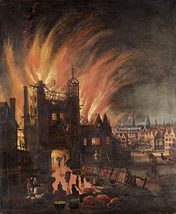

In Art and Design, we will be…

* Investigating painting techniques
* Colour mixing
* Using charcoal
* Making our own 3D models of Tudor houses

In Science we will be learning about…

* Materials and their properties
* Designing and making umbrellas and boats
* Investigating the properties of paper

Image result for seaside

In our PSHE sessions we will be learning about:

* Getting on and falling out
* Making the right choices
* Respect
* What is fair and unfair
* Anti bullying week

In Music, we will be learning the songs for our Winter production.

In PE, we will be focusing on agility and improving static balances.

Our topic for R.E is Christianity and Christmas. Our big questions is: Why did God give Jesus to the world?

In Computing we will be…

* Sequencing commands
* Simple programming
* Safe internet searching

What caused the Great Fire of London?