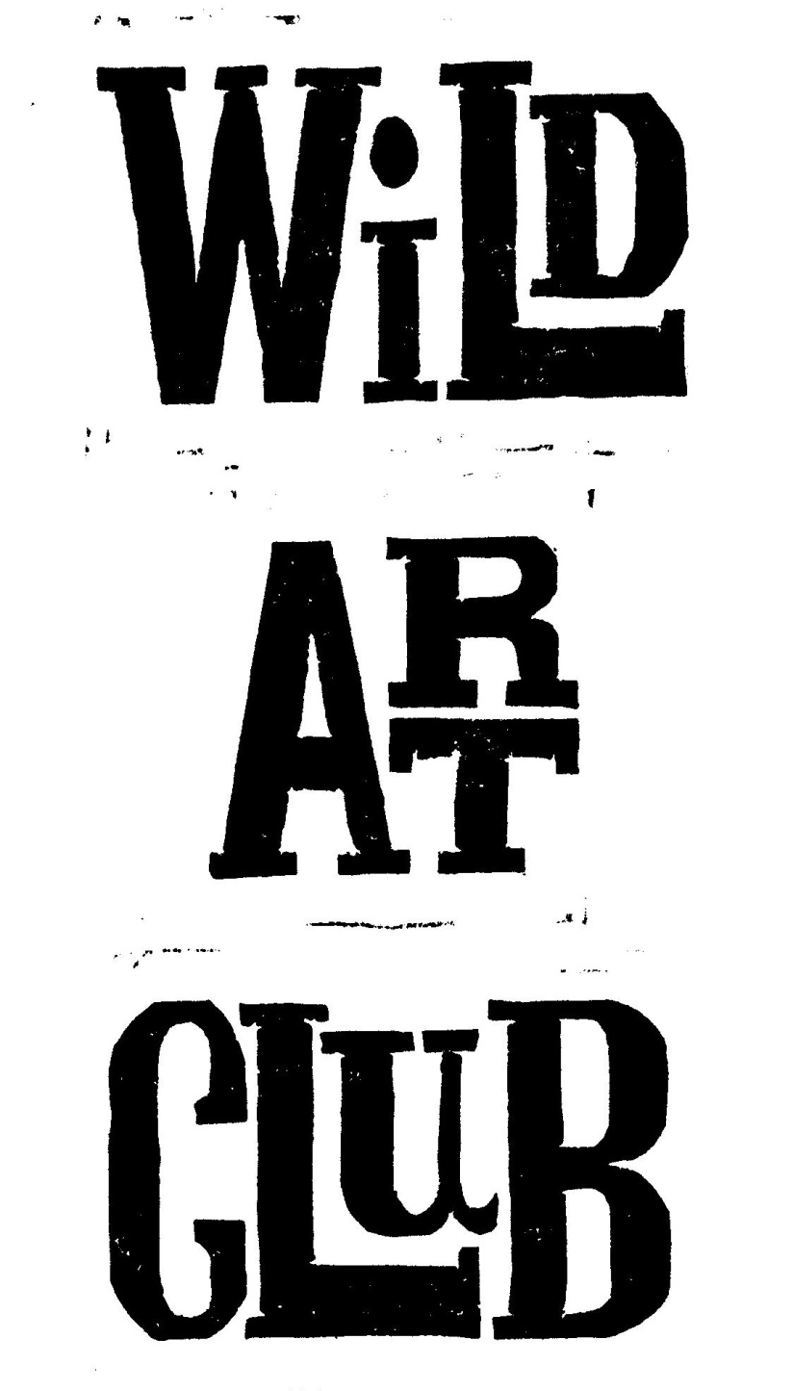 Please speak to me if there is a problem and

**Follow the club on Instagram to see the children’s artwork:**

**Wild Art Club. Summer Term 2018.**

Enjoy Exploring Wildlife at School, through hands-on experience and Art & Craft activities, with Maggie Spratt.

**Wild Art Club will run for 12 sessions** **during the Summer Term** **on Tuesdays,** **from 3pm to 4.30pm.**

**Starting on 24th Apr – 17th July, at a cost of £60 each.**

**Open to Years R, 1, 2, 3 & 4.**

Please make sure that your child has an old painting shirt to wear, as sessions can get messy! A healthy snack is welcome, no sweets please. Good Behaviour is Expected At All Times. Please be on time to collect children at the end of each session. **Cost for the term is £60.00, payable by cheque, cash or BACS to Mrs M Spratt Sort Code 202662 Account Number: 60703338 Payable as a single payment of £60 by 24th April, or two payments of £25 to be paid by the 24th Apr & £35 to be paid by the 5th June 2018.** Consent Form & Payment must be returned by 24th Apr 2018 to ensure your child’s place, & numbers may be restricted depending on availability of adult helpers. Please detach and return form to School Reception. Please speak to me if there is a problem and I will try to accommodate you: [mrspratt@hotmail.co.uk](mailto:mrspratt@hotmail.co.uk) 01258-837927/07929-832662



**Wild Art Club Summer Term 2018.**

Name of Child………………………………………………………………………………………………Year..………………………………

Email Address………………………………………………………………………………………………………………………………………

Contact Telephone No…………………………………………………………………………………………………………………………..

Please state if your child has any relevant medical conditions/allergies……………………………………………..………….

I am happy for my child to be photographed for publicity………..………………………………………………………..………

I enclose payment of £60.00 for the whole term or £25.00 for first ½ Summer Term 2018 / £35.00 for 2nd ½ Summer Term 2018. (Please circle as applicable).

Signed…………………………………………..………Print Name……………………….....…………..……..…….Parent/Guardian