**Home Learning**

You can help your child’s learning at home by:

* Listening to your child read a variety of books. Encouraging them to complete their reading record.
* Helping them to practise their spelling words in a variety of ways, for a short time each day.
* Encouraging independence- getting their book bag ready themselves etc

1. 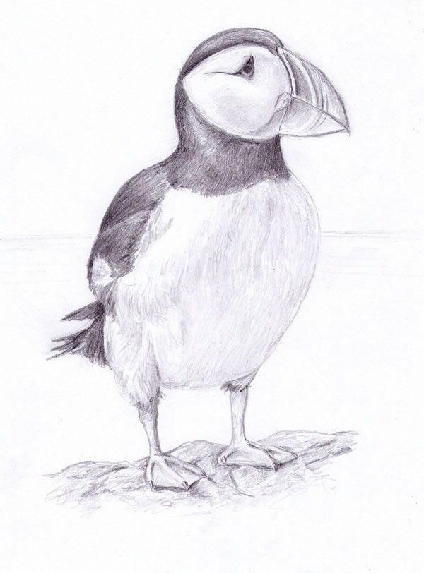

**Home Learning Expectations**

The expectation is that each child will:

* Read at least 3 times a week
* Learn the spellings that are sent home.
* Complete a maths or literacy homework activity once a week.
* Complete any occasional homework set as part of a topic or science.

**Important**

Please ensure your child brings a PE kit to school on Monday and leaves it at school during the week. It can be taken home at the weekend. Please check that trainers fit comfortably.

Please remind your child to bring their spelling book & reading records in on Fridays.

**Playtime snacks/ water bottles.**

Government do not provide snacks for KS2 children so please send your child with extra fruits or vegetables for playtime. Water bottles should be named and only contain water. With the weather hopefully warming up, please ensure your child has sufficient water for the day.

### .

KS2: Puffins

Spring term 1 2018

Jaunary 2018

**Class Teachers: Miss Young**

**Adult support: Mrs Dutton**

Please take time to read about what we will be learning in school during the next half term. If you have any questions please see Miss Young .

**Dates for your diary**

February 8th Y4 Tree planting with trees for Dorset.

**Our Main Themes this Half Term**

[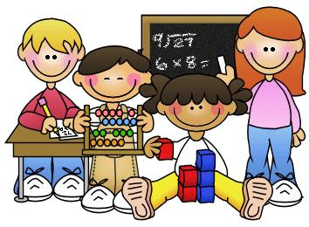](http://www.google.co.uk/url?sa=i&rct=j&q=&esrc=s&source=images&cd=&cad=rja&uact=8&ved=0ahUKEwjJotewsbrTAhUHKMAKHc0QDW8QjRwIBw&url=http://clipart-library.com/maths-cliparts.html&psig=AFQjCNGsEtWnynmlRjUaHYtyuTo3932Y2g&ust=1493030273715196)

Topic

We will be focusing on learning through Geography. Our key question is; Why is the sunshine state such an important holiday destination.

The children will learn about, climate, different states, and even practice some of their map reading skills.

Literacy

In literacy we will be learning about the different types of instructions, thinking in particular about how our instructions change depending on who is reading them!.

We will also be starting our new spelling programme and learning new ways to remember them!

In our SPaG lessons we will be focussing on verb inflections and fronted adverbials.

Science

In Science we will be looking at states of matter and learning about the different stages of solids, liquids and gases. The children will also begin to learn all about sound finding out all there is to know about sound waves, pitch and frequencies.

Maths

In Maths we will be learning about fractions & decimals as well as gaining a better understanding of multiplication and division.

In statistics we will be using pie charts, bar charts and pictograms to represent our findings.

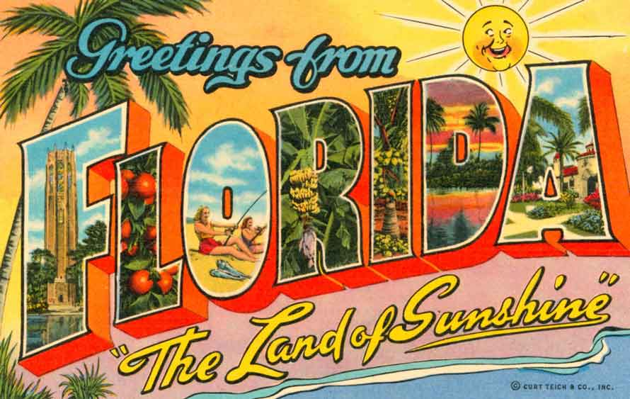

Computing

The children are going to start their new and exciting coding lessons with an outside provider on Friday afternoons.

PE

Year 3 will continue swimming this term and Year 4 will start athletics.

Our topic focus question: **Why is the sunshine state and important holiday destination?**

R.E

IN R.E the children are going to be learning about the Easter story.

Jigsaw Relax kids

The children will be taking in mindfulness workshops with staff relax kids.

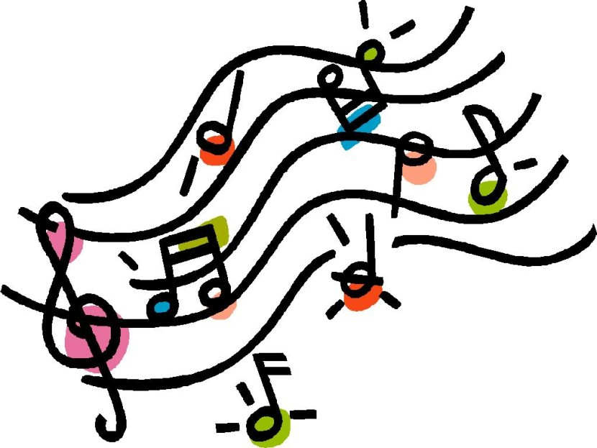

Music

Year 4 children will be practising for their concert with Dorset Music Service.

Y3 will be leaning how to compose simply melodies simply percussion.