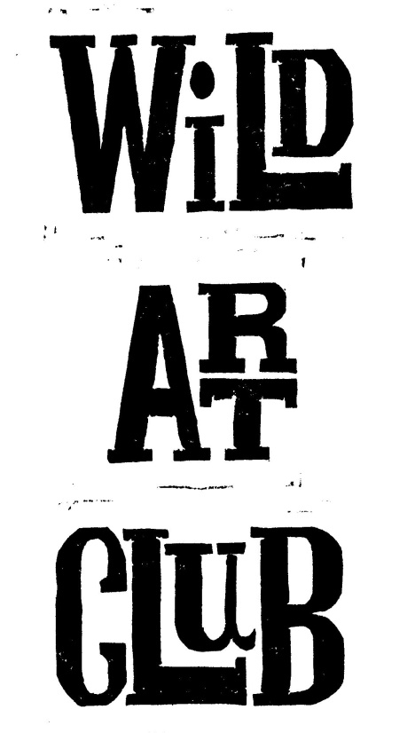
Summer Term 2018.
As the problems of plastic pollution are receiving widespread coverage, next term’s topic will be based on the theme of “Rubbish” and how we can reuse and recycle it creatively.
For the first half of the term activities will be linked to “Spring”, and will include nesting birds, flowers and insects.
The second half of the term will involve activities that are connected to “The Sea”.
All sessions will explore the nature of rubbish, its original use, material make-up and recycling possibilities, followed by an opportunity to use and upcycle the items in a fun and imaginative way.
So please could you encourage your children to start collecting the items on the list below, as they will be requiring them for their creations! There will be prizes for those that bring everything in!
- For the first half of the term, please can all club members bring in;
Week 1 – 24th April – some cardboard packaging, an old magazine, sweet wrappers and some straws
Week 2 – 1st May – a smooth-sided litre drinks bottle and some bottle caps
Week 3 – 8th May – empty juice cartons, tetra packs, jam jar lids and Easter egg foil (not crushed!)
Week 4 – 15th May – drinks cans (not crushed!) and a pair of gloves to wear for protection
Week 5 – 22nd May – lots of bottle tops (beer, milk, water, etc.) and an egg box
- For the second half of the term, please can all club members bring in;
Week 6 – 5th June – plastic bags, an egg box and clean empty crisp packets
Week 7 – 12th June – 500ml plastic drinks bottles and sweet wrappers
Week 8 – 19th June – a plastic milk bottle, milk bottle tops and some straws
Week 9 – 26th June – jam jar lids and bottle caps
Week 10 – 3rd July - silver foil or aluminium food containers
Week 11 – 10th July – a smooth sided litre drinks bottle
Week 12 – 17th July – a smooth sided 500ml drinks bottle and a kinder-egg capsule
PLEASE ENSURE ALL ITEMS ARE WASHED, DRIED AND READY TO USE. THANK YOU.

