I wonder who he is?

The man I wish to tell you about is plump and old and he has grey hair and wrinkled skin, he lives in a small cottage and he is a toy maker. Furthermore, he has won lots of trophies for toy making but is not lucky enough to have any children of his own to give them to. Overall he is a happy man and he has made toys like globes, electric toys that talk and move and also he has made toy fossils too.
Sadly, the children in his village were poor so he sneaks out and delivers toys onto their doorsteps at night time. He loves to eat biscuits while he is working in his cottage and his tummy is getting round and his trousers are getting tight.
One day the elves from the Enchanted Forest came to see him and asked if he would like a big cottage to make his toys in and then deliver them to children all around the world, he could use his globe to find out where to go.
I think you know everything about him now, do you know who he is?.....
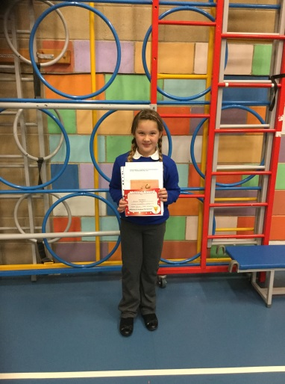
YES! That’s right he is Father Christmas!

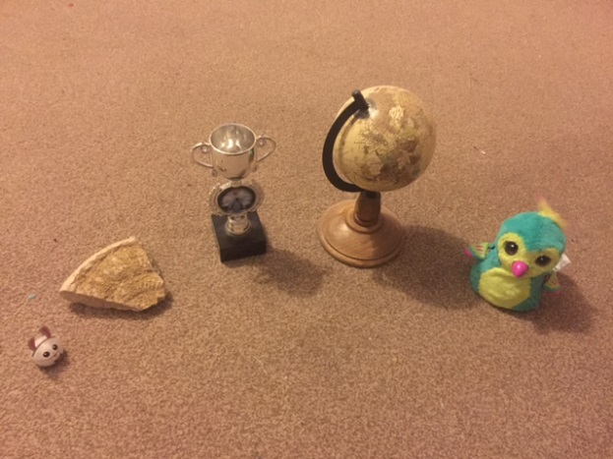
My objects for my character description were:-
Trophy
Fossil
Globe
Hatchimal
Ozobot

