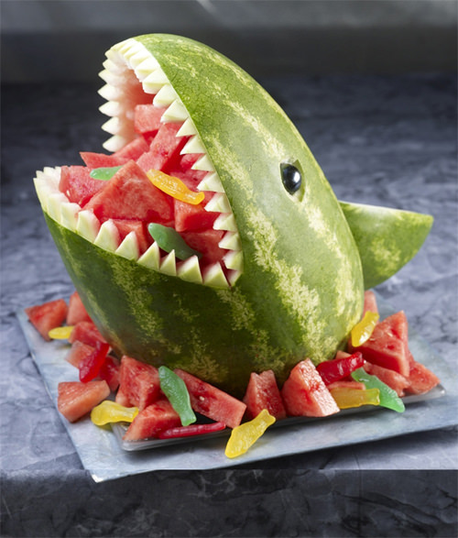
Dolphins Topic Homework Summer 2018

This half term we are learning all about food.
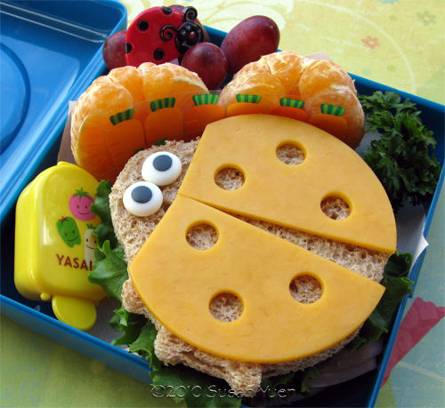
It’s time to get creative and make some ‘Food Art’. You have to make a piece of art using any food that you like. You then have to take a picture for your homework books. Make sure you write down what you used to make your art and how you made it.

If you are able to, please bring your pieces of art into school to show the class.

For some inspiration visit: http://www.thedailybuzz.com.au/2011/ 10/20-creative-food-ideas-for-kids/
Or simply search “Food Art” on the internet.

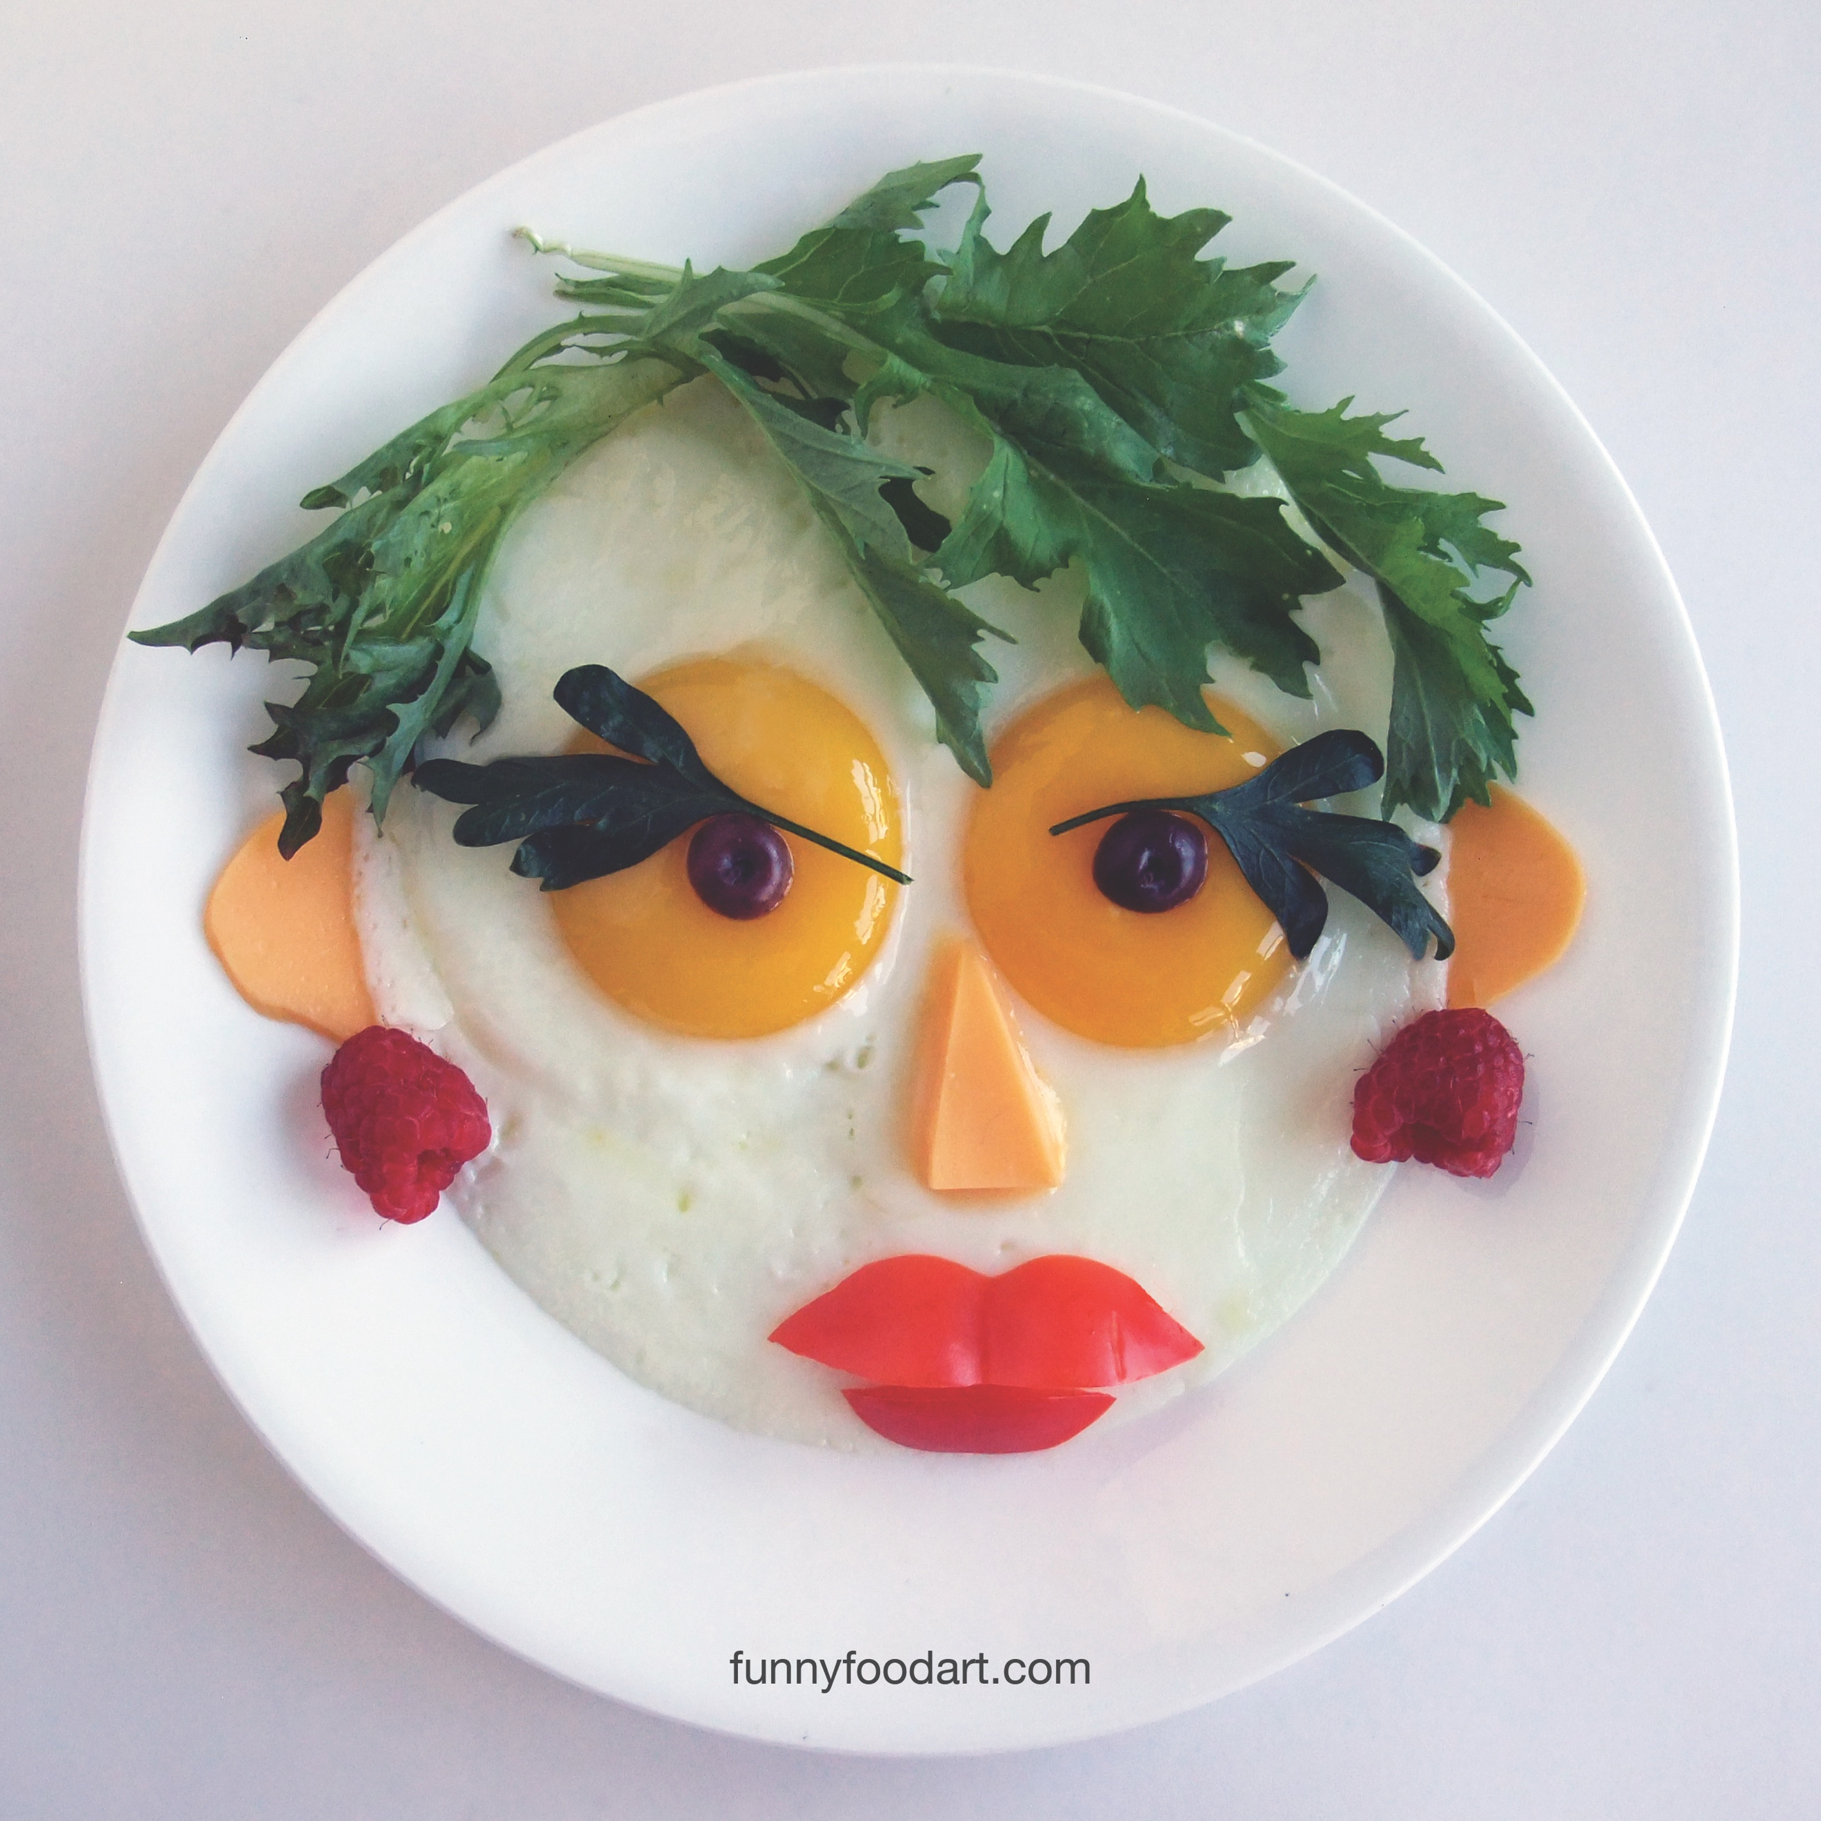
Have fun!
