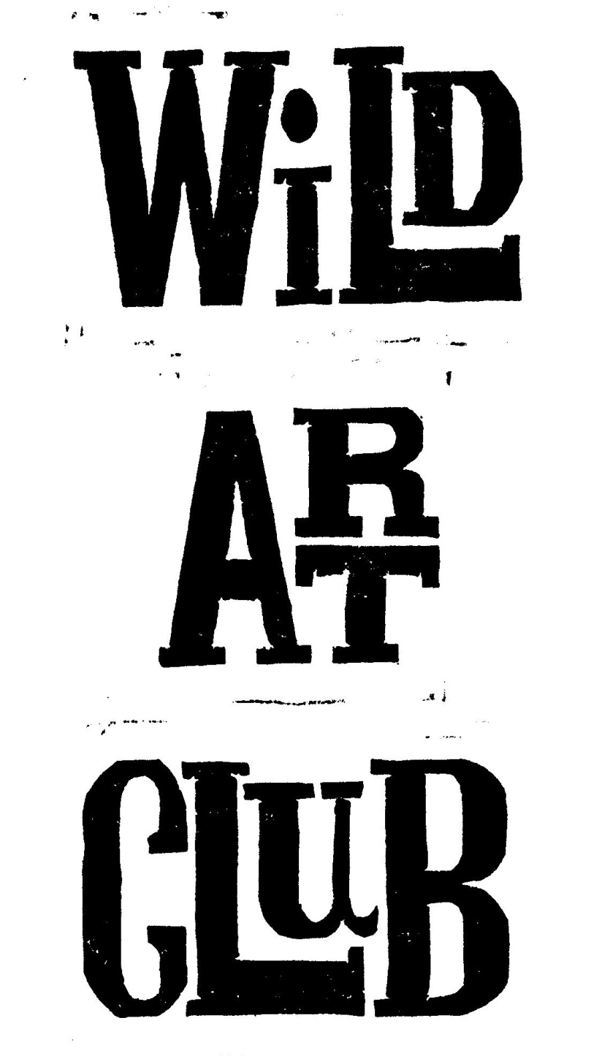

**Wild Art Club. Summer Term 2017.**

Enjoy Exploring Wildlife at School, through hands-on experience and Art & Craft activities with Maggie Spratt.

**Wild Art Club will run for 10 sessions** **during the Summer Term, for Years R, 1, 2, 3 & 4 on Tuesdays only.**

**Starting on 2nd May & running until the 11th July, from 3.00- 4.30pm at a cost of £50 each.**

Please make sure that your child has old clothes and suitable footwear for outside, & an old painting shirt to wear, as sessions can get messy! We will be outside in the grounds when weather permits. A healthy snack is welcome, no sweets please. Good Behaviour is Expected At All Times. Please be on time to collect children at the end of each session.

**Cost for the term is £50.00, payable to Mrs. M. Spratt by 2nd May 2016.**

(Payable as a single payment of £50, or two payments of £20 & £30 to be paid by the 2nd May & the 6th June)

Consent Form & Payment must be returned by 2nd May to ensure your child’s place, & numbers may be restricted depending on availability of adult helpers. Please detach and return form to School Reception. Please speak to me if there is a problem and I will try to accommodate you: [mrspratt@hotmail.co.uk / 07929](mailto:mrspratt@hotmail.co.uk%20/%2007929) 832662

[mrspratt@hotmail.co.uk](mailto:mrspratt@hotmail.co.uk)

01258-837927/07929-832662

Child…………………………………………………………………………………………………………..………………………………

Address……………………………………………………………………………………………………………………………………………………..

Contact Telephone No…………………………………………………………………………………………………………………………….

Please state if your child has any relevant medical conditions/allergies…………………………………

I am happy for my child to be photographed for publicity………..…………………………………………………..

I enclose payment of **£45.oo for the term. ./ £25.00 for first ½ term.**

Signed……………………………………………………………………………………………………………………..…….Parent/Guardian

**Wild Art Club Summer Term 2017.**

Name of Child………………………………………………………………………………………………Year..………………………………

Address…………………………………………………………………………………………………………………………………………………

Contact Telephone No…………………………………………………………………………………………………………………………..

Please state if your child has any relevant medical conditions/allergies……………………………………………..………….

I am happy for my child to be photographed for publicity………..………………………………………………………..………

I enclose payment of £50.00 for whole term / £20.00 for 1st half of Term/ £30.00 for 2nd half of Term (Please circle)

Signed………………………………………………………………………………………………..…………..……..…….Parent/Guardian